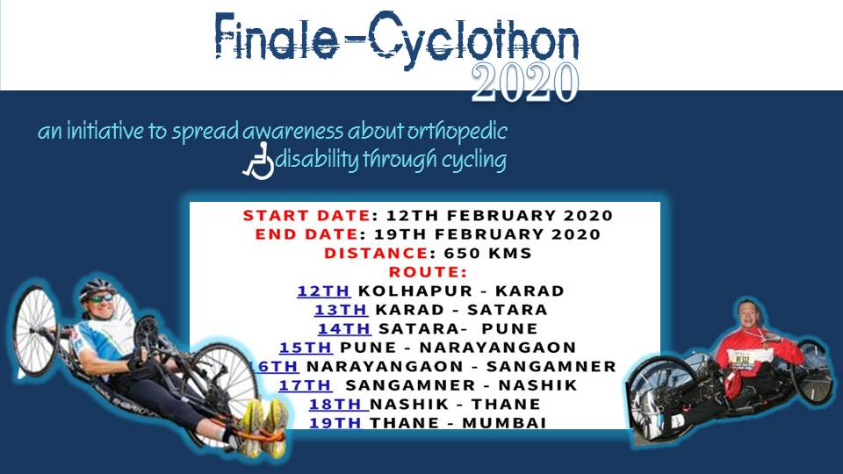

Dear Sir/ Madam,

IMC Chamber of Commerce and Industry is supporting Ratna Nidhi Chairtable Trust in organizing an event to felicitate Mr. Stefan Voormans for his valiant endeavor and give credits to all stake holders who will be completing Cyclothon 2020 from Kolhapur to Mumbai in 7 days on February 19, 2020 at 06.00 pm at Walchand Hirachand Hall, 4th Floor, IMC. The Chief Guest of the event is Shri. Sumit Mullick, State Chief Information Commissioner, Government of Maharashtra.

Cyclothon 2020 is an initiative to spread awareness about orthopedic disability through cycling. Mr Stefan Voorman, an inspiration for many physically disabled individuals, who would be completing cycling from Kolhapur (Maharashtra) to Mahalakshmi (Mumbai) covering a distance of about 650 kms over a span of a week. We aim to create awareness for the empowerment of people with disabilities by organizing a Cyclathon 2020.

We extend our cordial invitation to join us for this august gathering. To register send your confirmation to Ms Anita Naik on anita.naik@imcnet.org or call us on+91 22 71226666.
Kindly note there are no registration fees, but registration is MANDATORY due to limited number of seats. We look forward to your participation.

Ajit Mangrulkar
Director General,
IMC Chamber of Commerce and Industry

